ReactJS Hands-on 7 - Shopping App Using Props

Commands Used
- npx create-react-app shoppingapp
- cd shoppingapp
- npm start

Project Structure
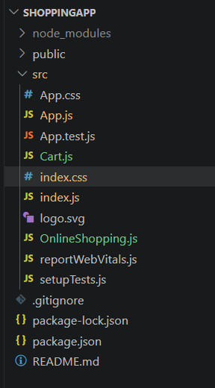

App.js
import React from "react";
import OnlineShopping from "./OnlineShopping";
function App() {
return (
<div>
<OnlineShopping />
</div>
);
}
export default App;

OnlineShopping.js
import React, { Component } from "react";
import Cart from "./Cart";
class OnlineShopping extends Component {
render() {
const CartInfo = [
{ itemname: "Laptop", price: 80000 },
{ itemname: "TV", price: 120000 },
{ itemname: "Washing Machine", price: 50000 },
{ itemname: "Mobile", price: 30000 },
{ itemname: "Fridge", price: 70000 }
];
return (
<div>
<h1>Items Ordered :</h1>
<Cart item={CartInfo} />
</div>
);
}
}
export default OnlineShopping;

Cart.js
import React, { Component } from "react";
class Cart extends Component {
render() {
return (
<table border="1">
<thead>
<tr>
<th>Name</th>
<th>Price</th>
</tr>
</thead>
<tbody>
{this.props.item.map((item,index)=>(
<tr key={index}>
<td>{item.itemname}</td>
<td>{item.price}</td>
</tr>
))}
</tbody>
</table>
);
}
}
export default Cart;

index.js
import React from "react";
import ReactDOM from "react-dom/client";
import "./index.css";
import App from "./App";
const root = ReactDOM.createRoot(document.getElementById("root"));
root.render(
<React.StrictMode>
<App />
</React.StrictMode>
);

index.css
body{
font-family: Arial;
margin:40px;
}
table{
border-collapse: collapse;
}
th,td{
padding:8px 20px;
}

Expected Output

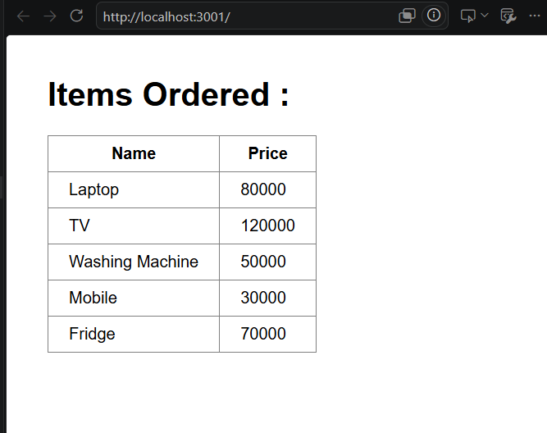

Conclusion
The shopping application was implemented successfully using React class components and props. The Cart component received data from the OnlineShopping component through props and displayed the items in a tabular format.

